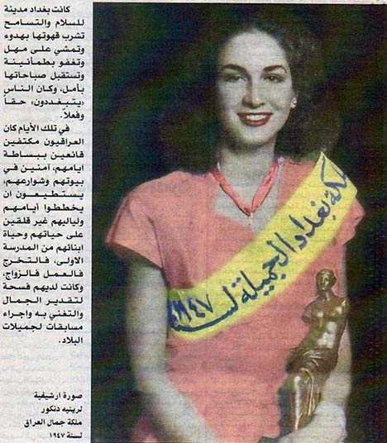Baghdad used to be a city of peace and tolerance, where people enjoyed calmly drinking their coffee, strolling with ease, retiring at night with confidence, and waking up in the morning with a new hope. People were really living the good life.

In those days, Iraqis were satisfied with the simplicity of their lives, feeling secure in their homes and streets. They were able to plan their days and nights without any fear for their lives or those of their children from primary school on to graduation, career and marriage. And they also had the opportunity to value beauty and appreciate it and even to hold beauty contests:

Archive photo of Renée Dangoor, Beauty Queen of Iraq 1947

